Title of Paper Here Abstract Template for AToMS2021

First name Family name of Primary Author *
Email address of Primary Author
First name Family name of next author *
First name Family name of next author #

*1st affiliation address, # 2nd affiliation address etc.

KEY WORDS: List up to five key words.

Please put your abstract text, figures, tables and any references here. The maximum length of the abstract is one page, and must be prepared using the format given in this document. Please do not change font, font sizes, or spacing. Body text should be written in Arial, 10 pt, single spacing. Please do not add separate sections, page numbers or headers or footers. References can be included at the bottom [1]. Please proof your abstract carefully prior to submission. The abstract should be submitted as Word File (.doc or .docx).

The abstract can contain images, graphs or tables, but please note that these will be printed in black and white.

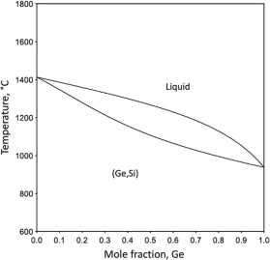

Table 1. Table data
Structure | Phase | Enthalpy of formation, kJ/mol
tI32 Cr₅B₃ | Nb₅Ge₃ | -46.53
 | Nb₅Si₃ | -61.2
tI32 W₅Si₃ | Nb₅Ge₃ | -46.63
 | Nb₅Si₃ | -58.2

Further abstract text here. Further abstract text here. Further abstract text here. Further abstract text here. Further abstract text here. Further abstract text here. Further abstract text here. Further abstract text here. Further abstract text here. Further abstract text here. Further abstract text here.

Further abstract text here. Further abstract text here. Further abstract text here. Further abstract text here. Further abstract text here. Further abstract text here. Further abstract text here. Further abstract text here. Further abstract text here. Further abstract text here. Further abstract text here.

[1] I. Papadimitriou, C. Utton, P. Tsakiropoulos, On the Nb-Ge binary system, Metall. Mater. Trans. A 46 (2015) 5526-5536.

