The Mining Institute of Scotland
Technical Meeting
Wednesday, 16 December 2020 at 17:30 hours

Energy Storage using Underground Shafts

Presented by
Charlie Blair, Managing Director of Gravitricity Limited

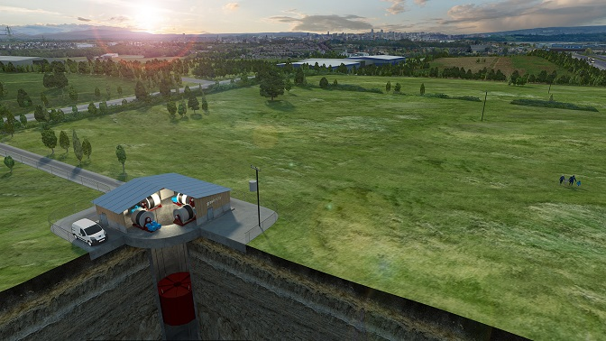

Abstract
Charlie Blair, MD of Edinburgh-based Gravitricity Limited, will talk about the Company’s grid-scale energy storage technology which uses vertical underground shafts – mineshafts or purpose-sunk new shafts. His talk will introduce the global requirements for Energy Storage and explain why Gravitricity’s ‘solid-state pumped hydro’ technology is particularly interesting. He will then look at how Energy Storage can play a role in both mine-closure plans and as part of a Renewable Energy System for operating mines, and go into more detail on Gravitricity’s project development activities at mineshaft sites in Europe and South Africa.
Bio
Charlie joined Gravitricity in 2015 having been Head of Marine Energy in the Carbon Trust's Innovation Team. He has 15 years’ experience in clean energy technology innovation and has supported numerous early-stage technology start-ups ranging from electric vehicles through to biomass heating. Charlie is a fellow of the Energy Institute and member of the Institution of Engineering and Technology.

Registration
If you wish to hear Charlie, you will have to register with our Secretary (d.seath@btinternet.com) to generate a link to the online platform.

